PlaceCom
Placement BFSI Analyser
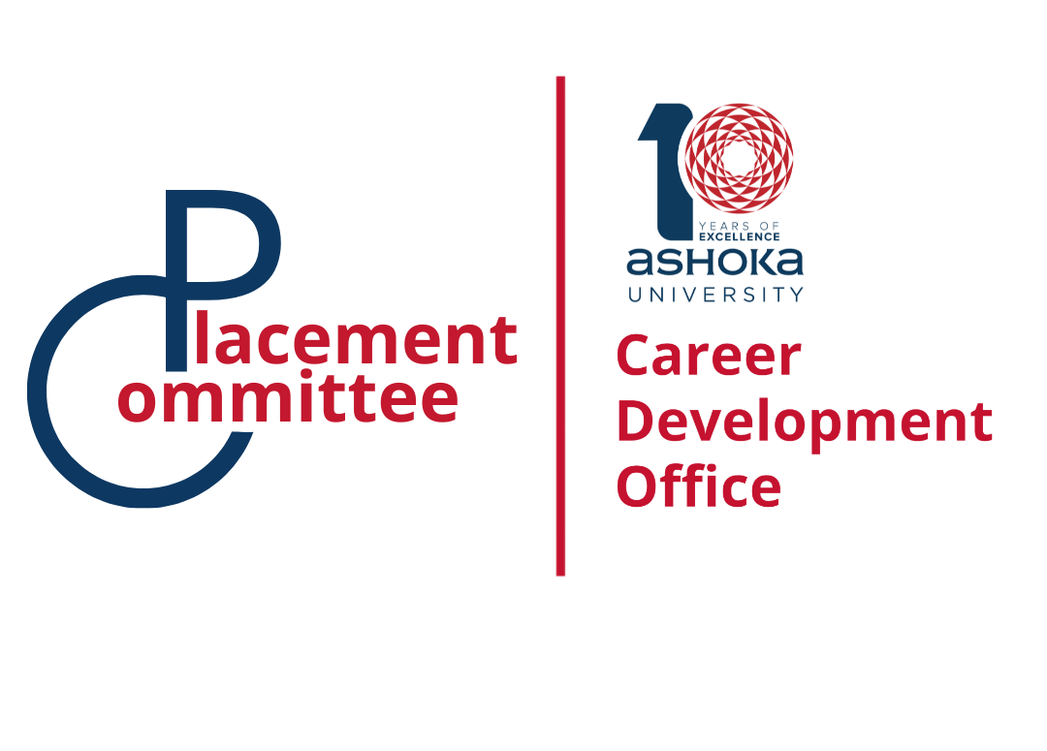

An HR interview is usually one of the final stages of the hiring process. Unlike technical interviews that test job-specific knowledge, the HR round focuses more on who you are as a professional. The interviewer wants to understand your personality, communication skills, motivation, and whether you will fit well within the company’s culture. In simple terms, HR is assessing whether hiring you will benefit both the organization and the team you will work with.
While the conversation may feel informal, it is still a structured evaluation. HR professionals typically assess several core qualities during the discussion:
- Communication skills – how clearly and confidently you express ideas
- Professional attitude – maturity, responsibility, and behavior
- Cultural fit – whether your values align with the company
- Career motivation – why you want the role and where you want to grow
- Reliability and integrity – honesty and consistency in your answers
Because of this, the HR interview is not just about answering questions correctly; it is about demonstrating that you would be a positive and dependable addition to the organization.

Understanding the Structure of an HR Interview
Most HR interviews follow a predictable structure. The interviewer typically begins with general questions to help you feel comfortable and to understand your background. A common starting point is the classic “Tell me about yourself.”
A good answer should briefly cover three parts:
- Your current role or recent experience
- Relevant past achievements or education
- Your interest in the role you are applying for
This structure keeps the response focused and professional instead of turning it into a life story.

Questions About Motivation and Career Choices
After the introduction, the interviewer often explores your motivations. These questions help them understand whether you genuinely want the role or are simply applying broadly.
Typical questions include:
- Why do you want to work at this company?
- What interests you about this position?
- Why are you leaving your current job?
Strong answers connect your personal career goals with the company’s mission or opportunities. Employers want candidates who are enthusiastic about contributing to the organization rather than those who view the job as a temporary stop.

Strengths, Weaknesses, and Self-Awareness
Another common section of the HR interview focuses on your self-assessment. Interviewers may ask about your strengths, weaknesses, and work habits. These questions help determine your level of self-awareness and honesty.
When discussing strengths, it is helpful to support them with real examples. For instance, instead of simply saying you are a good problem solver, briefly describe a situation where you solved a problem successfully.
When discussing weaknesses, the goal is not to admit a critical flaw but to demonstrate growth. A strong response usually includes:
- A genuine but manageable weakness
- How you recognized it
- Steps you are taking to improve
This approach shows maturity and willingness to learn.

Behavioral Questions and Real Experiences
Many HR interviews also include behavioral questions, which focus on how you handled past situations. Employers believe that past behavior is often the best predictor of future performance.
These questions often begin with phrases like:
- “Tell me about a time when…”
- “Describe a situation where…”
- “Give an example of…”
A useful framework for answering these questions is the STAR method:
- Situation: Briefly describe the context
- Task: Explain the responsibility or challenge
- Action: Describe what you did
- Result: Share the outcome or lesson learned
Using this structure keeps your answers organized and clear.

Discussing Salary and Practical Details
Toward the end of the interview, HR may bring up logistical topics such as salary expectations, availability, notice period, or relocation.
Before the interview, it is important to research the typical salary range for the role and location. When asked about expectations, it is usually better to provide a reasonable range rather than a fixed number. This shows flexibility while still communicating your market value.
For example, a balanced response might explain that your expectations are based on your experience and industry standards, while also emphasizing that you are open to discussing the full compensation package.

The Importance of Body Language and Communication
HR interviews evaluate not only what you say but also how you present yourself. Non-verbal communication can strongly influence the impression you make.
Good practices include:
- Maintaining comfortable eye contact
- Sitting upright with confident posture
- Speaking clearly and at a moderate pace
- Listening carefully before responding
At the same time, it is important to avoid behaviors that may signal discomfort or lack of professionalism, such as interrupting the interviewer, speaking negatively about past employers, or appearing uninterested.

Asking Questions at the End
Most HR interviews end with the interviewer asking if you have any questions. This moment is important because it demonstrates curiosity and genuine interest in the organization.
Thoughtful questions might include:
- How is success measured in this role?
- What does the onboarding process look like?
- How would you describe the company culture?
- What are the opportunities for growth within the team?
Asking meaningful questions shows that you are thinking seriously about the role and how you can contribute.

